POWER BI
URBAN PULSE- Report
Star Schema Data Model, Executive Dashboard & Weather Analytics Dashboard
Prepared: July 2026

1. Executive Summary
This report documents an end-to-end business intelligence project built in Power BI that brings together demographic, urban mobility, public transport and weather data into a single analytical model. The model follows a star schema design — one central date dimension surrounded by three fact tables (Weather, Mobility and Transport) plus supporting Stop and Transport dimensions — so that all three domains can be sliced consistently by time.
Two dashboards were delivered on top of this model:
- Executive Dashboard — a transportation performance overview combining vehicle volumes, traffic speed, boarding counts and temperature into a single operational view, filterable by year and month.
- Weather Analytics Dashboard — a deep-dive into long-run climate trends (temperature, humidity, pressure) and weather-summary distribution, filterable by month.
Across the combined datasets (roughly 111,000 rows spanning 2006–2024), traffic conditions were most frequently classed as High (63% of mobility readings), average traffic speed sat at 42.1 km/h, and the long-run average temperature was 11.9°C with average humidity of 73%. These figures anchor the KPI cards on both dashboards.

2. Project Objective
The goal of the project was to design a single, reusable data model that lets stakeholders move between city-level demographic context, real-time-style mobility conditions, scheduled public transport performance and historical weather patterns without switching tools. The specific objectives were to:
- Consolidate four independently-sourced datasets into one star schema in Power BI.
- Build a shared Date dimension so mobility, transport and weather metrics can be compared on the same timeline.
- Deliver an Executive Dashboard summarising overall transportation performance for leadership.
- Deliver a Weather Analytics Dashboard for operational and planning teams tracking climate trends that affect mobility.

3. Data Sources
Four source files were ingested into the model. Together they cover roughly 111,000 rows across demographic, mobility, transport and weather domains, described below.
Dataset | Grain / Coverage | Rows | Role in Model
Demographic Dataset | 38 Tamil Nadu districts | 38 | Reference data for population, literacy and density context alongside transport demand
Mobility Dataset | 5-min interval sensor reads, 1–18 Mar 2024 | 5,000 | Feeds Fact Mobility — vehicle counts, traffic speed, emissions, ride-share demand, sentiment
Transportation Data | Route/stop boardings by week, Jun 2013–Jul 2014 | 10,000 | Feeds Fact Transport — boardings by route, stop and trip
Weather History | Hourly weather readings, 2006–2016 | 96,453 | Feeds Fact Weather — temperature, humidity, pressure, visibility, wind

3.1 Demographic Dataset
Contains one row per district (38 districts) with population, area, population density, literacy rate, sex ratio, urban/rural split and growth rate. Total population across all districts is approximately 76.5 million, average literacy rate is 79.5%, and average annual growth rate is 9.0%. Chennai is the most populous district at roughly 4.65 million residents, followed by Vellore and Tiruvallur.

3.2 Mobility Dataset
5,000 sensor-style records taken at 5-minute intervals between 1–18 March 2024, capturing vehicle counts, traffic speed, road occupancy, traffic-light state, weather condition at the time, accident reports, ride-sharing demand, parking availability, emission levels and a sentiment score. Traffic conditions were logged as High in 63% of readings, Medium in 30% and Low in 7%. Average emission level is 272 g/km and average road occupancy is 54.7%.

3.3 Transportation Data
10,000 records of public-transport boardings by route, stop and trip, spanning weekly periods from June 2013 to July 2014, across 365 routes and 3,506 stops. Total recorded boardings across the period are approximately 47,500. The busiest stops recorded were on King William St and Grenfell St, each logging 700+ boardings over the period.

3.4 Weather History
96,453 hourly weather observations from 2006 to 2016, including temperature, apparent temperature, humidity, wind speed and bearing, visibility, pressure and a text weather summary. "Partly Cloudy" and "Mostly Cloudy" together account for roughly 62% of all readings, with the remainder split between Overcast, Clear, Foggy and other conditions.

4. Data Model — Star Schema
The four source tables were shaped into a star schema with a shared Dim_Date at the centre, connecting to three fact tables (Fact_Weather, Fact_Mobility, Fact_Transport). Fact_Transport also relates to a Dim_Transport (route/trip) and a Dim_Stop (stop ID and name) dimension, while Fact_Weather relates to a Dim_Weather dimension carrying the daily/precipitation summary text. This structure keeps each fact table narrow and numeric while descriptive attributes live in the dimensions, and it lets every visual on both dashboards filter by the same Year / Month / Quarter hierarchy.
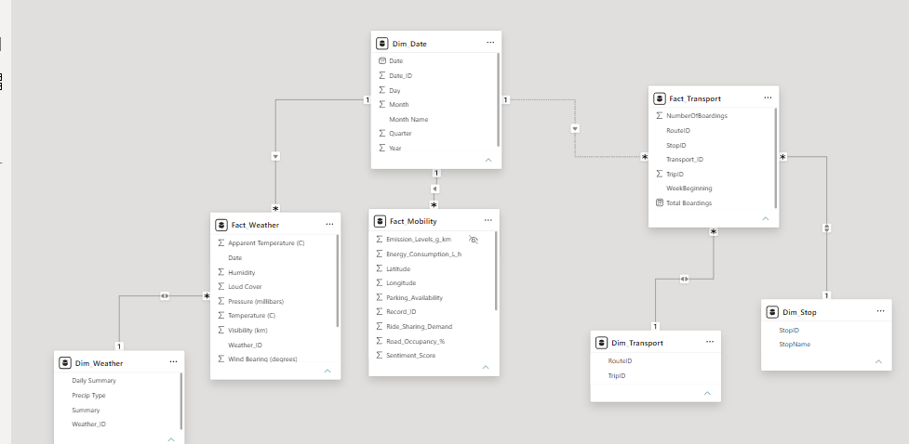
Figure 1 — Star schema: Dim_Date at the centre with Fact_Weather, Fact_Mobility and Fact_Transport, plus Dim_Weather, Dim_Transport and Dim_Stop.

4.1 Table Roles
- Dim_Date — Date, Date_ID, Day, Month, Month Name, Quarter, Year. The single time hierarchy shared by all three fact tables.
- Fact_Weather — Apparent Temperature, Humidity, Loud Cover, Pressure, Temperature, Visibility, Wind Bearing, linked to Dim_Weather (Daily Summary, Precip Type, Summary).
- Fact_Mobility — Emission Levels, Energy Consumption, Latitude/Longitude, Parking Availability, Ride-Sharing Demand, Road Occupancy %, Sentiment Score.
- Fact_Transport — NumberOfBoardings, Total Boardings, RouteID, StopID, TripID, WeekBeginning, linked to Dim_Transport (RouteID, TripID) and Dim_Stop (StopID, StopName).
Relationship cardinality is one-to-many from every dimension out to its fact table (1 : *), which is the standard star-schema pattern and keeps DAX measures additive and predictable.

5. Executive Dashboard
The Executive Dashboard gives leadership a single-screen view of transportation performance, combining vehicle mobility data, boarding counts and temperature. It is filterable by Year (slider) and Month (checklist).
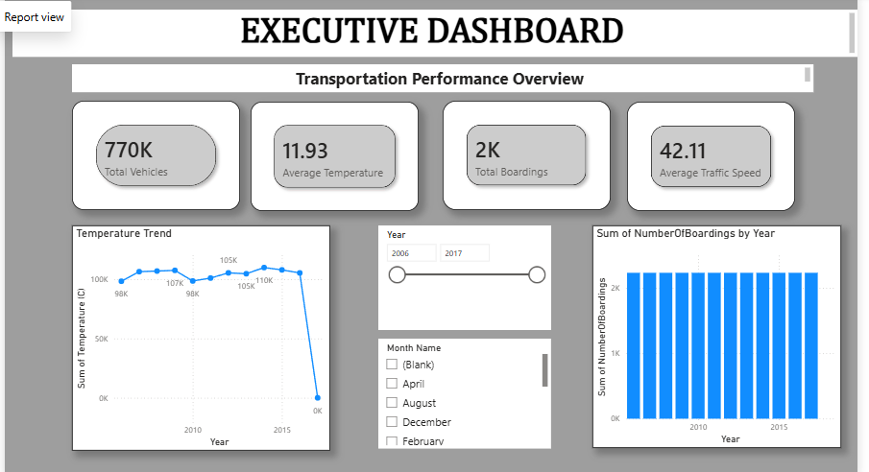
Figure 2 — Executive Dashboard: KPI cards, Temperature Trend, Sum of NumberOfBoardings by Year, and Year/Month filters.

5.1 KPI Cards
KPI | Value | Source
Total Vehicles | 770K | Fact_Mobility — sum of Vehicle_Count
Average Temperature | 11.93°C | Fact_Weather — average Temperature (C)
Total Boardings | 2K | Fact_Transport — sum of NumberOfBoardings (current filter context)
Average Traffic Speed | 42.11 km/h | Fact_Mobility — average Traffic_Speed_kmh

5.2 Visuals
- Temperature Trend (line chart) — sum of temperature by year, 2006–2017; the sharp drop at the right edge reflects a partial/blank year in the current filter selection rather than an actual climate shift.
- Sum of NumberOfBoardings by Year (column chart) — boardings held steady at roughly 2K per year across the observed range, indicating stable ridership.
- Year slider and Month Name checklist — let a viewer isolate any year between 2006–2017 or a specific month to re-cut every visual on the page.
6. Weather Analytics Dashboard
The Weather Analytics Dashboard is aimed at planning and operations teams who need to understand long-run climate patterns that influence mobility and transport demand. It is filterable by Month using a range slider.
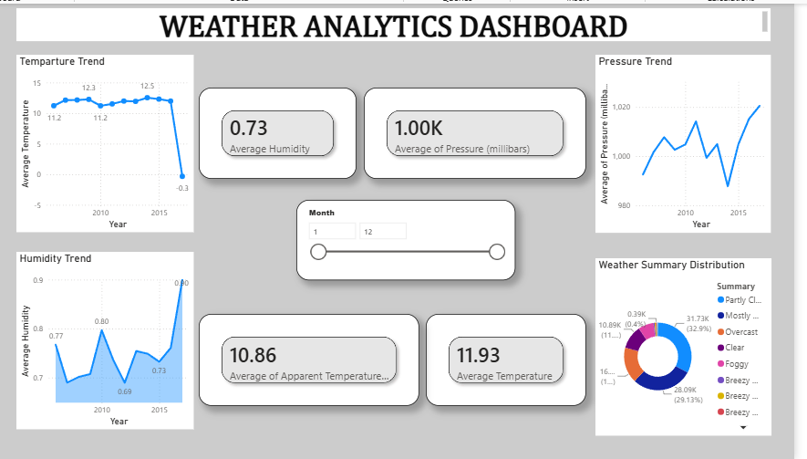
Figure 3 — Weather Analytics Dashboard: Temperature Trend, Pressure Trend, Humidity Trend, KPI cards and Weather Summary Distribution donut.

6.1 KPI Cards
KPI | Value | Source
Average Humidity | 0.73 | Fact_Weather — average Humidity
Average Pressure | 1.00K millibars | Fact_Weather — average Pressure (millibars)
Average Apparent Temperature | 10.86°C | Fact_Weather — average Apparent Temperature (C)
Average Temperature | 11.93°C | Fact_Weather — average Temperature (C)

6.2 Visuals
- Temperature Trend — average temperature by year; broadly flat between 11–13°C from 2006–2015 with the same end-of-range dip seen on the Executive Dashboard.
- Pressure Trend — average pressure by year, fluctuating between roughly 980–1,020 millibars with no sustained upward or downward drift.
- Humidity Trend — average humidity by year, ranging from about 0.69 to 0.90, with a visible spike at the most recent year in view.
- Weather Summary Distribution (donut) — Partly Cloudy (32.9%) and Mostly Cloudy (29.13%) dominate, followed by Overcast (~10.9K records), Clear, Foggy and Breezy variants.
- Month range slider — narrows every visual on the page to a chosen month span.

7. Conclusion
The star schema successfully unifies four otherwise-separate datasets around a common date hierarchy, and the two dashboards give leadership and operations teams complementary views — one operational (Executive Dashboard) and one climate-focused (Weather Analytics Dashboard) — without duplicating logic.

